Gabriel Emerson

ELEC2210 T 11

Experiment 8: Free Space Optical Communication Link

03/9/21

The objectives of this lab were to experiment with IR LEDs and photo transistors working together. Also, another concept was to experiment with free space communication using the IR optical source in conjunction with the photo transistor. Finally, we are to view AM and FM waves while varying the amplitudes and frequencies of both these types of waves by using an arbitrary waveform generator (ARB). All this is to be accomplished while developing professional communication skills.

**Step 1:**

V to I conversion. The SFH4110 IR LED was inserted on the ELVIS II board. The positive node (anode) of the IR LED was connected to DUT+ terminal, and the negative node (cathode) to the DUT- terminal. Using the 2-wire analyzer we measured I-V characteristics of the IR LED forward voltage sweep from 0.5 to 1.4V in steps of 0.02V. The results are shown in Figure 1.

Using the data file from the graph, the voltage needed to produce approximately 15mA of current was recorded. The voltage was 1.226V

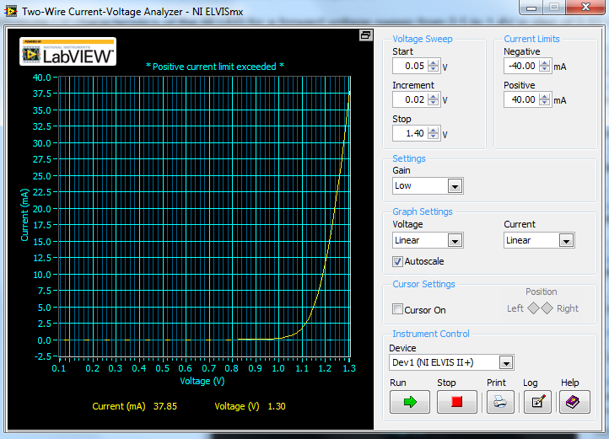

Figure 1: Measured voltage to current conversion (I-V) characteristics of the IR LED

We then added a 510 \Omega resistor in series with the IR LED. The I-V measurement on the IR LED and resistor in series was repeated. From the 15mA diode voltage recorded in the previous step, we calculated the sweep voltage upper limit such that our measurement will stop when the current is around 15mA.V­­­­limit = Vr + Vled = (15mA)*(510\Omega) + 1.226V=8.876V

The voltage increment was set to such that approximately 20 data points were measured:

Vlimit/20 = 0.4438A. From the data file of the graph the voltages needed to produce approx. 5mA and 10mA of current were measured and recorded to be 3.936V and 6.556V respectively. The result is shown in Figure 2.

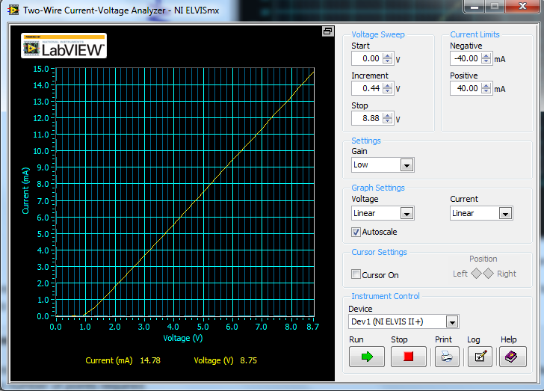

Figure 2: MEasured voltage to current conversion (I-V) characteristics of the transmitter

The difference between the I-V graphs with and without the resistor is that in the second graph (with resistor) the current versus voltage increases linearly. On the other hand when there is not a resistor the current increases exponentially very fast. The role of the resistor is to have a linear conversion of voltage to current to recover a wave at the receiver output. The diode current increases with voltage exponentially, making the light emitted and the detector output a nonlinear function of the input voltage. That is why we need to add a resistor in series with the LED because it will help limiting the current. Also, it produces negative feedback that helps linearize the voltage to light conversion process, and increases the dynamic range as well.

**Step 2:**

In this section we measured the photo transistor characteristics using the 2-wire analyzer that was designed for diode measurement. The IR LED and resistor combo was placed near the photo transistor. The VPS was used to control the LED current and intensity of light emission. The VPS output voltage was set to 3.936V, the value recorded in previous part for approximately 5mA LED current. The collector was connected to DUT+ and the emitter to DUT-. The I-V curve of the photo transistor was measured with the 2-wire analyzer and are shown in Figure 3.

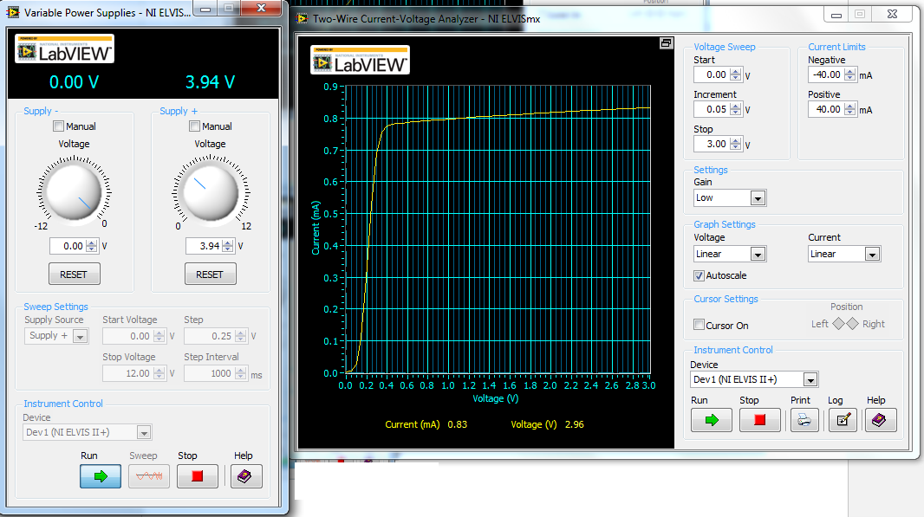

Figure 3: measured I-V of the photo transistor with a LED nearby emitting light, the absorption of which produces an internal base current

Then the measurement with the other voltage recorded earlier for approximately 10mA IR LED current was performed. The result is shown in Figure 4.

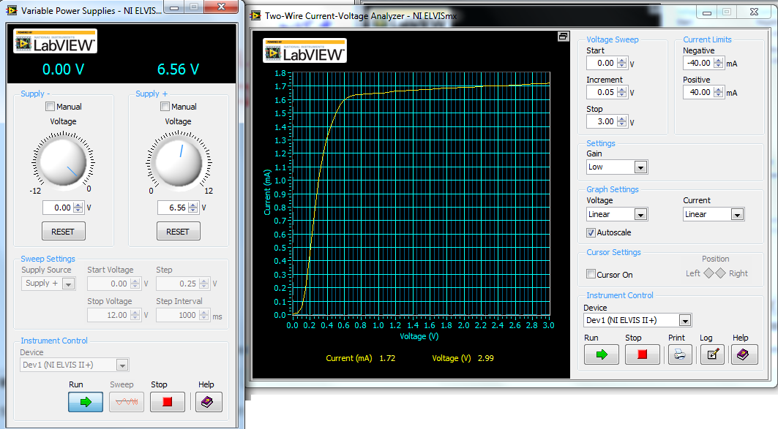

Figure 4: measured I-V of the photo transistor with a LED nearby emitting light, the absortion of which produces an internal base current

The phototransistor I-V curve looks very similar as the I-V curve of the 2N3904 used in previous labs. The ratio of forward mode collector current to the LED current was measured for both measurements. At 3.936V the ratio is 0.815mA/5mA =0.163 and at 6.556V the ratio is 1.7mA/10mA = 0.17.

**Step 3:**

The circuit shown in Figure 5 was constructed based on the previous part. The SFH4110 was used for the IR LED (light emitter). The SDP8406 was used for the photo transistor (detector). The dots of the SFH4110 IR LED and the SDP8406 photo transistor were placed such that they faced each other to create a direct light path. The transmitter and the receiver were spaced 2 holes apart. The R1 resistor had a value of 510Ω and R2 a value of 4.5kΩ. The Vcc voltage was set to 5V

The analog signal from the function generator output was connected to the input of the circuit. This input controls the current and hence the light emission of the IR LED. Then the photo transistor output was connected to AI 0+ and the function generator output to AI1+. The AI 0- and AI 1- terminals were grounded. The settings for the FGEN were set to be 1 Vpp and DC offset 1V.

Transmitted and received signals are shown in Figure 5. In this figure the output (green wave) was clipped meaning that there was too little of light received.

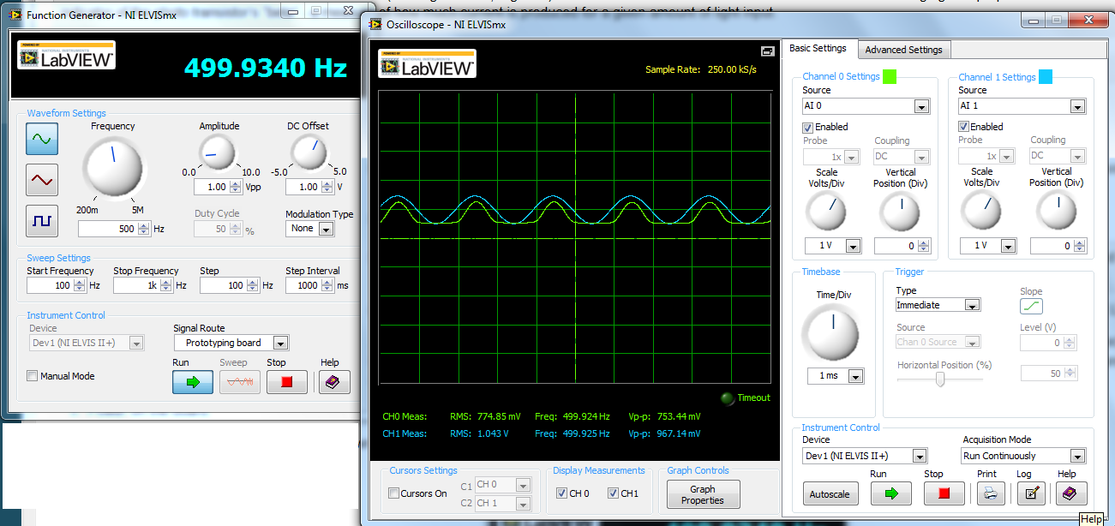

Figure 5: transmitted and distorted received signals when the dc offset is too low such that IR LED cuts off during the negative half cycle.

By increasing the dc offset the lowest output of FGEN was above turn-on voltage of the IR LED allowing significant light emission, so the full output sine wave was seen. The result of the working link is shown in Figure 6.

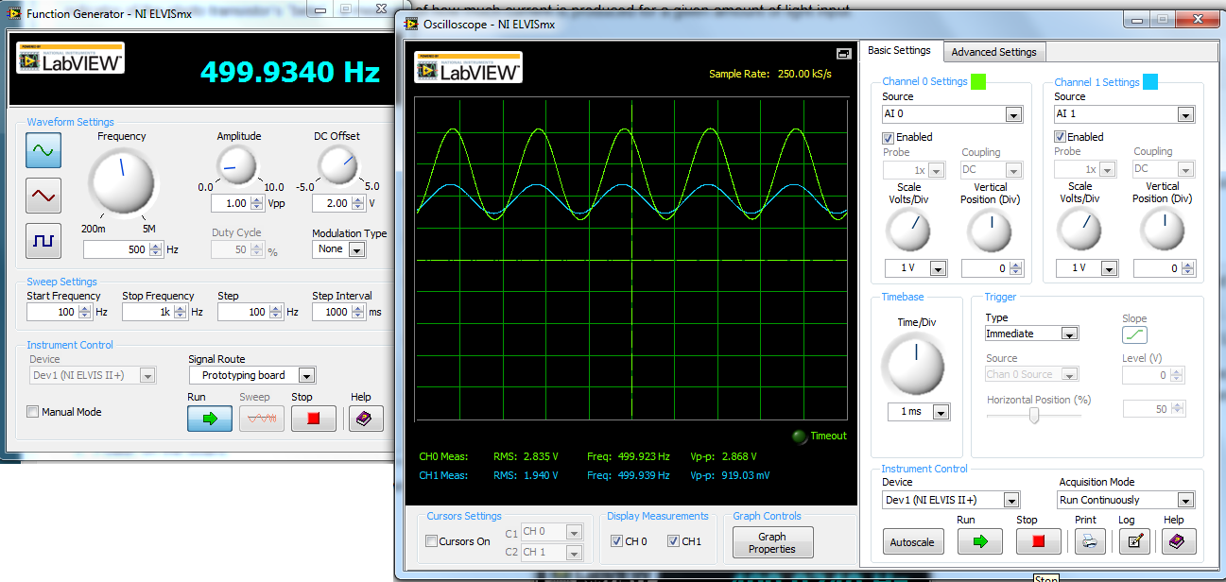

Figure 6: transmitted and received signals working link using the free space optical link

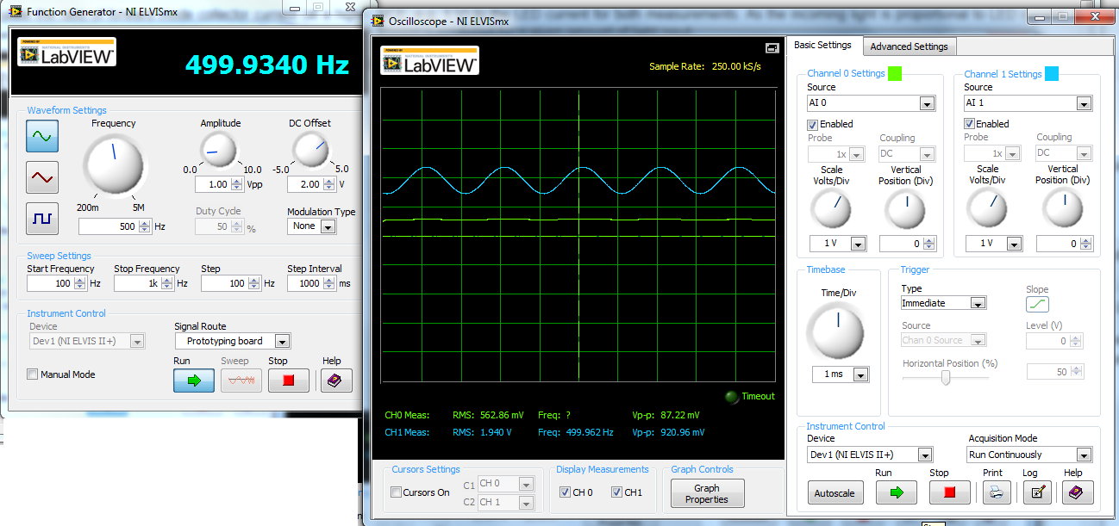Then light was blocked between the IR Led emitter and the photo transistor IR detector by placing a piece of paper between them. The received signals is very weak and the results is shown in Figure 7.

Figure : transmitted and received signals using the free space optical link when a piece of paper blocks the infrared light.

Then the spacing between the emitter and receiver was increased and the results are shown in Figure 8.

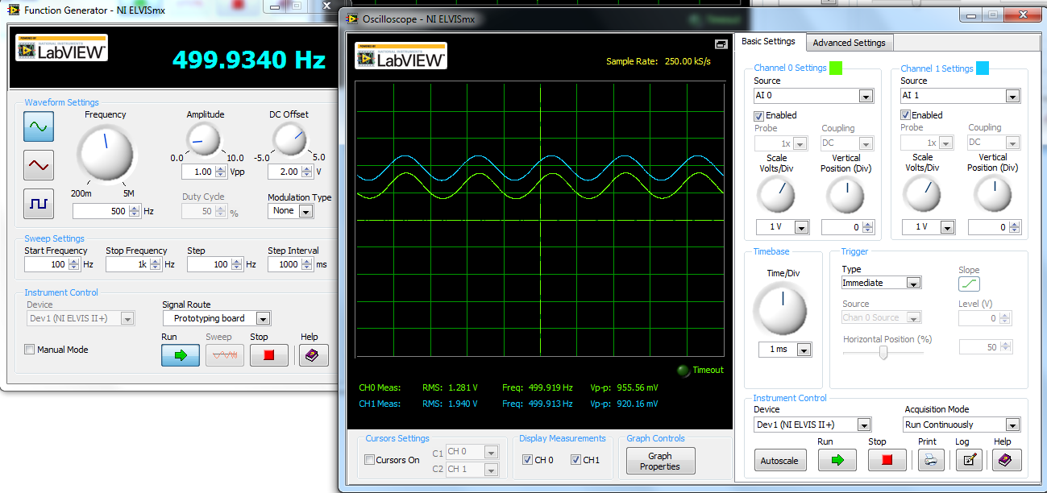

Figure 8:transmitted and received signals using the free space optical link when the spacing between emitter and receiver was increased

Then the emitter and transistor pair was removed and replaced by the OPB804 optocoupler. The results are shown in Figure 9.

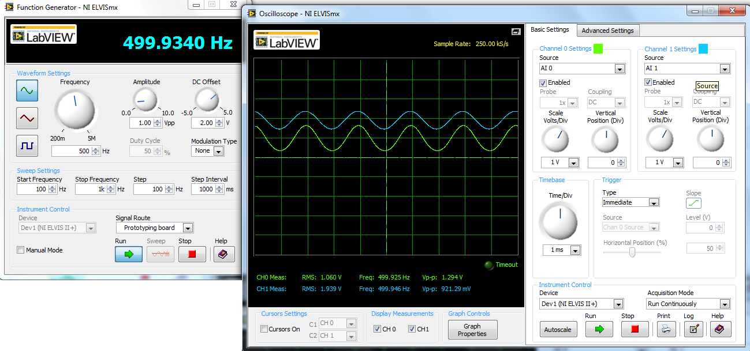

Figure 9:transmitted and received signals using the free space optical link of the optocoupler

**Step 4:**

Amplitude Modulation (AM Wave)

In this section the POB804 optocoupler was removed and the IR LED and photo transistor were again connected. The AO 0 was connected to AM input of FGEN. The AM was selected from the modulation type drop down menu in the FGEN setting.

The Arbitrary Waveform Generator (ARB) was opened and the enabled box for AO0 was checked. The waveform generator was used to generate a waveform. The square-sine wave was specified shown in Figure 10. The transmitted and received AM signals are shown below in Figure 11.

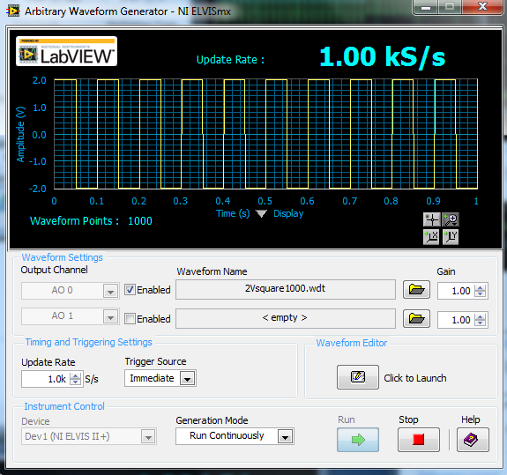

Figure 10: arbitrary waveform generator screen

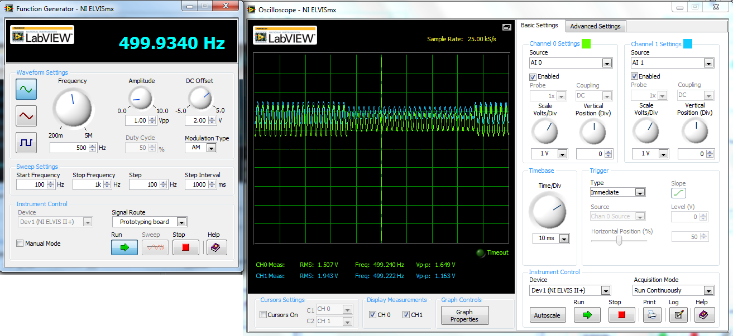

Figure 11: Transmitted and received AM signals

Our measured amplitude is consistent with hand calculations. A = Ac * (1 + K(10%)*V(in)), therefore, A = 1V*(1+0.1*2V) = 1.2 V. Our measured amplitude was 1.163 V.

**Step 5:**

Frequency modulation (FM Wave)

In this section the FM modulation was selected in FGEN. The AO 1 was connected to FM input of FGEN. The box for A0 1 was checked. The square-sine wave was specified and is shown in Figure 12. The transmitted and received AM signals are shown below in Figure 13.



Figure 12: arbitrary waveform generator screen

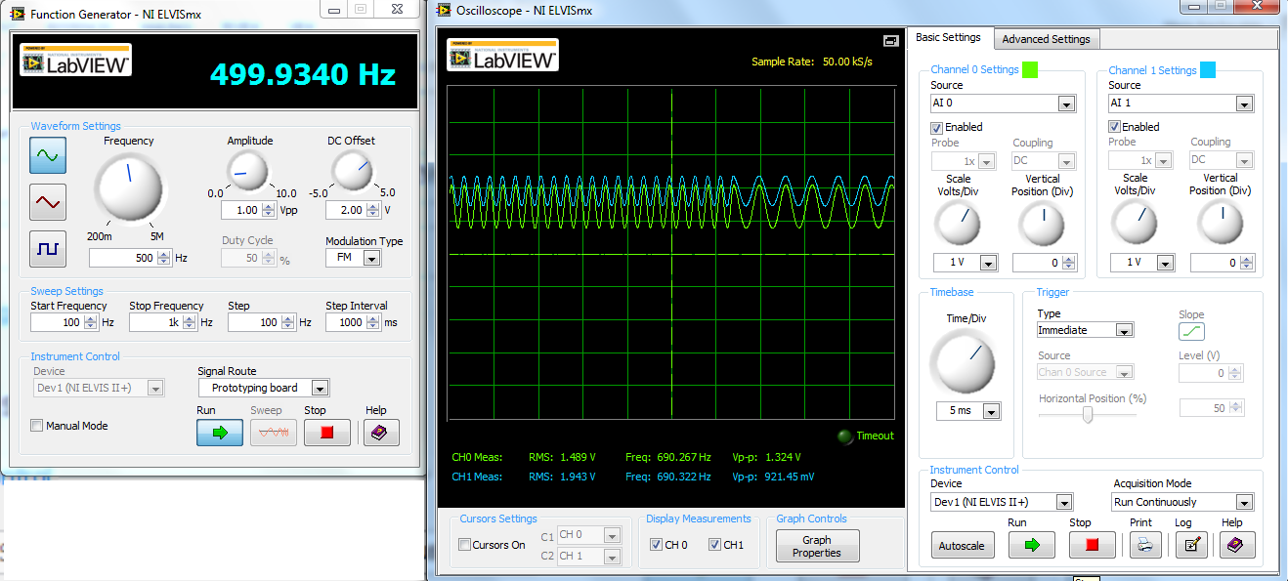

Figure 13: Transmitted and received FM signals

Overall, this lab was successful. At first, I struggled to get the correct waveforms and did not understand what we were wanting the result of the wave to be. However, after getting more instruction, it became easier to see what we really were looking for. After this, my calculations and simulations went together easily.

